**Project Design Phase**

**Solution Architecture**

| Date | 15 February 2025 |
| --- | --- |
| Team ID | LTVIP2025TMID59424 |
| Project Name | Citizen AI – Intelligent Citizen Engagement Platform |
| Maximum Marks | 4 Marks |

**Solution Architecture:**

Solution architecture is a complex process – with many sub-processes – that bridges the gap between business problems and technology solutions. Its goals are to:

### Solution Architecture – 5 Key Points

1. **Layered Architecture**: The system follows a modular structure—Frontend (HTML, JS), Backend (Flask + FastAPI), AI Layer (OpenAI/Granite), Database (SQLite), and Dashboard (Chart.js).
2. **AI-Driven Communication**: Uses IBM Granite/OpenAI for real-time, intelligent chatbot replies and sentiment analysis on citizen feedback.
3. **Offline & Scalable**: Designed to work offline using SQLite and Flask, with future scalability via cloud (IBM Cloud, Docker) and mobile platforms.
4. **Dynamic Dashboard**: Admin dashboard visualizes sentiment trends using real-time charts and enables data-driven governance.
5. **Future-Ready Design**: Easily extendable for multilingual support, geo-tagging, role-based dashboards, and predictive analytics.

**Example - Solution Architecture Diagram:**

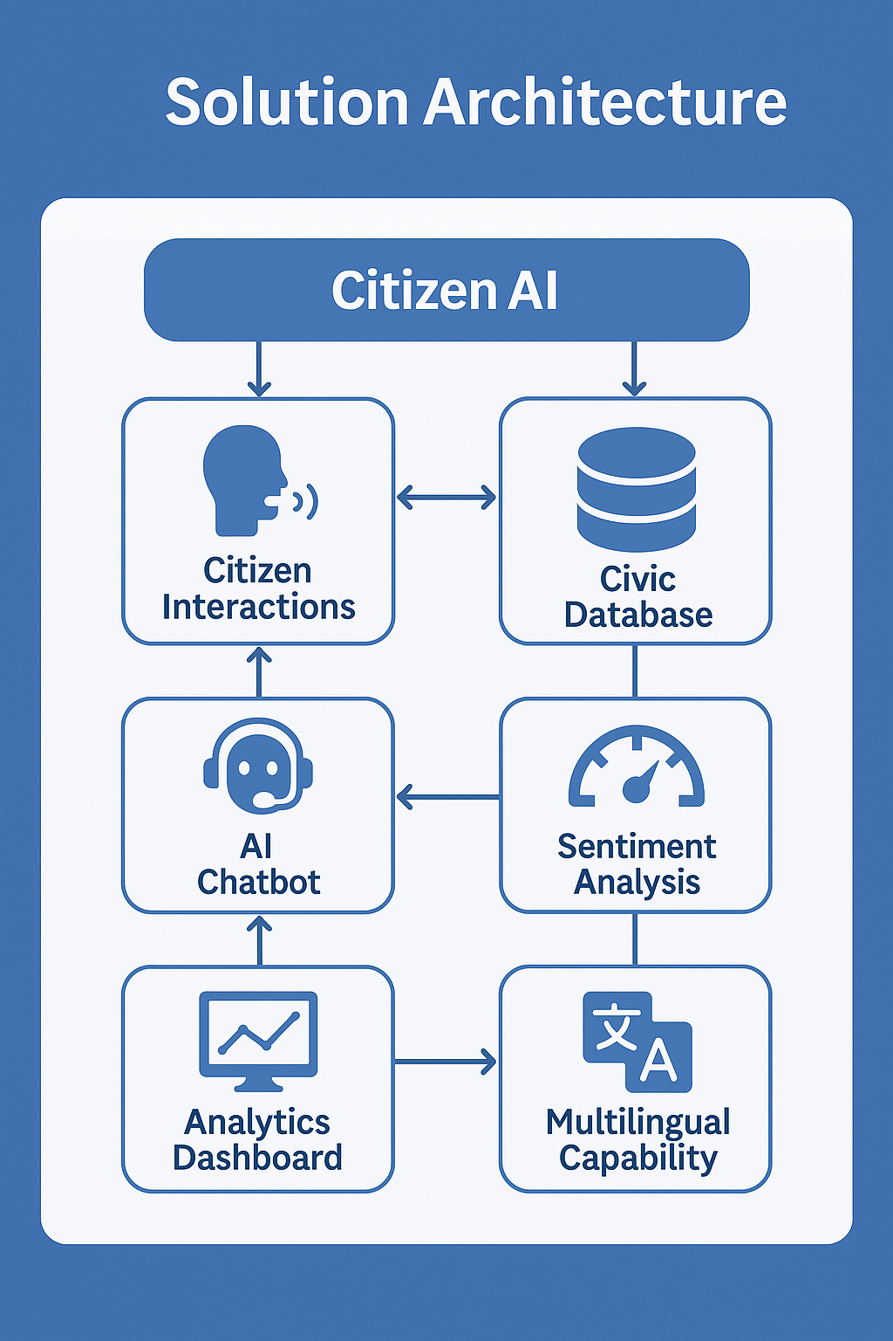

*Figure 1: Architecture and data flow of the voice patient diary sample application*

**Reference:** [**https://aws.amazon.com/blogs/industries/voice-applications-in-clinical-research-powered-by-ai-on-aws-part-1-architecture-and-design-considerations/**](https://aws.amazon.com/blogs/industries/voice-applications-in-clinical-research-powered-by-ai-on-aws-part-1-architecture-and-design-considerations/)